**Placify-Me**

**A PROJECT REPORT**

**for**

**Mini Project (KCA353)**

**Session (2023-24)**

**Submitted by**

**Tulika**

**2200290140162**

**Smriti Tiwari**

**2200290140153**

**Submitted in partial fulfilment of the**

**Requirements for the Degree of**

**MASTER OF COMPUTER APPLICATION**

**Under the Supervision of**

**Dr. Sangeeta Arora**

**Associate Professor**



**Submitted to**

**Department Of Computer Applications**

**KIET Group of Institutions, Ghaziabad**

**Uttar Pradesh-201206**

**(March-2024)**

**DECLARATION**

I hereby declare that the work presented in report entitled “Placify-Me” was carried out by me. I have not submitted the matter embodied in this report for the award of any other degree or diploma of any other University of Institute. I have given due credit to the original authors/sources for all the words, ideas, diagrams, graphics, computer programs, that are not my original contribution. I have used quotation marks to identify verbatim sentences and give credit to the original authors/sources. I affirm that no portion of my work is plagiarized, and the experiments and results reported in the report are not manipulated. In the event of a complaint of plagiarism and the manipulation of the experiments and results, I shall be fully responsible and answerable.

**Name:** Tulika

**Roll No.:** 2200290140162

**Name:** Smriti Tiwari

**Roll No.:** 2200290140153

**CERTIFICATE**

Certified that **Tulika 220029014094632, Smriti Tiwari 220029014088863** have carried out the project work having “**Placify-Me**” (**Mini Project-KCA353**) for **Master of Computer Application** from Dr. A.P.J. Abdul Kalam Technical University (AKTU**)** (formerly UPTU), Lucknow under my supervision. The project report embodies original work, and studies are carried out by the students themselves and the contents of the project report do not form the basis for the award of any other degree to the candidate or to anybody else from this or any other University/Institution.

**Date:**

**Tulika 2200290140162**

**Smriti Tiwari 2200290140153**

This is to certify that the above statement made by the candidate is correct to the best of my knowledge.

**Date:**

**Dr. Amit Kumar**

**Assistant Professor**

**Department of Computer Applications**

**KIET Group of Institutions, Ghaziabad**

**Placify-Me**

**Tulika**

**Smriti Tiwari**

**ABSTRACT**

Placify-Me is a pioneering online platform dedicated to transforming the landscape of placement preparation. This comprehensive website offers a strategic and personalized approach to guide individuals through every facet of the job-seeking journey. With features such as personalized skill development paths, a dynamic resume builder, a mock interview simulator, and real-time industry insights, Placify-Me powers users to navigate the competitive job market with confidence. The platform also prioritizes the psychological well-being of users, providing a toolkit for resilience. Additionally, the community support and networking feature fosters connections with peers and professionals, creating a collaborative environment. Placify-Me redefines placement preparation by amalgamating cutting-edge tools, personalized guidance, and a supportive community, ensuring users are well-prepared and positioned for success in their career pursuits.

**ACKNOWLEDGEMENTS**

Success in life is never attained single-handedly. My deepest gratitude goes to my thesis supervisor, Dr. Amit Kumar (Assistant Professor) for his guidance, help and encouragement throughout my project work. Their enlightening ideas, comments, and suggestions have guided me a lot in completing this project successfully.

Words are not enough to express my gratitude to Dr. Arun Kumar Tripathi, Professor and Head, Department of Computer Applications, for his insightful comments and administrative help at various occasions. Fortunately, I have many understanding friends, who have helped me a lot on many critical conditions.

Finally, my sincere thanks go to my family members and all those who have directly and indirectly provided me moral support and other kind of help. Without their support, completion of this work would not have been possible in time. They keep my life filled with enjoyment and happiness.

Tulika (2200290140162)

Smriti Tiwari (2200290140153)

|  |  |  |  |
| --- | --- | --- | --- |
|  | Declaration  **TABLE OF CONTENTS** | | ii |
|  | Certificate | | iii |
|  | Abstract | | iv |
|  | Acknowledgements | | v |
|  | Table of Contents | | vi |
| 1 | Introduction | | 8-11 |
|  | 1.1 | Overview | 8 |
|  | 1.2 | Problem Statement | 8 |
|  | 1.3 | Objectives | 9 |
|  | 1.4 | Scope | 9 |
|  | 1.5 | Feature | 9 |
|  | 1.6 | Hardware/Software Used | 10 |
|  |  | 1.6.1 Hardware Requirements | 10 |
|  |  | 1.6.2 Software Requirements | 11 |
| 2 | Feasibility Study | | 12-13 |
|  | 2.1 | Technical Feasibility | 12 |
|  | 2.2 | Operational Feasibility | 12 |
|  | 2.3 | Economical Feasibility | 12 |
|  | 2.3 | Behavioural Feasibility | 13 |
| 3 | System Requirements | | 14-16 |
|  | 3.1 Functional Requirements | | 14 |
|  | 3.2 Non-Functional Requirements | | 15-16 |
| 4 | Testing | | 17 |
|  | 4.1 Unit Testing | | 17 |
|  | 4.2 Integration Testing | | 17 |
|  | 4.3 System Testing | | 17 |
| 5 | Design | | 18-21 |
| 6 | Project Screenshot | | 22-30 |
| 7 | Conclusion and Future Scope | | 31 |
| 8 | Bibliography | | 32 |

**LIST OF FIGURES**

|  |  |  |  |
| --- | --- | --- | --- |
| **Figure No.** | **Name of Figure** | **Page No.** | |
| 5.1 | Flowchart | | 18 | |
| 5.2 | DFD | | 19 | |
| 5.3 | ER Diagram | | 20 | |
| 5.4 | Use Case Diagram | | 21 | |
| 6.1 | Home Page | | 22 | |
| 6.2 | User Sign up page | | 23 | |
| 6.3 | User Login page | | 23 | |
| 6.4 | User Dashboard | | 24 | |
| 6.5 | User Quiz page | | 24 | |
| 6.6 | User Score page | | 25 | |
| 6.7 | User History page | | 25 | |
| 6.8 | User Ranking page | | 26 | |
| 6.9 | Admin login page | | 26 | |
| 6.10 | Admin Dashboard | | 27 | |
| 6.11 | Add new quiz | | 27 | |
| 6.12 | Add quiz details | | 28 | |
| 6.13 | Remove quiz | | 28 | |
| 6.14 | Remove user | | 29 | |
| 6.15 | Test series questions | | 29 | |
| 6.16 | Test series result | | 30 | |
| 6.17 | Test series record | | 30 | |
|  |  | |  | |

**CHAPTER 1**

**INTRODUCTION**

**1.1 Overview**

Welcome to Placify-Me, your one-stop destination for comprehensive placement preparation! In today's dynamic job market, preparation is the key to success, and we understand the significance of equipping aspiring professionals with the right tools and resources to navigate the competitive landscape. Our Placement Preparation Planner is designed to empower students and job seekers by providing a curated collection of quizzes, tests, and study materials tailored to enhance their skills and knowledge.

Placify-Me is an innovative online platform designed to revolutionize student preparation for placements. With an extensive quiz library covering diverse topics and realistic full-length mock tests, the platform offers a personalized and efficient study experience. Customizable testing allows users to focus on specific areas, while real-time feedback and detailed performance analytics empower students to track their progress and understand their strengths and weaknesses. The user-friendly interface ensures seamless navigation, and discussion forums foster a collaborative learning community. Placify-Me aims to boost students' confidence, reduce anxiety, and provide a comprehensive solution for successful placement preparation, incorporating continuous updates to stay aligned with industry trends and exam patterns.

**1.2 Problem Statement**

Existing challenges in placement preparation include a lack of centralized platforms offering extensive quizzes, realistic mock tests, and detailed performance analytics. Current solutions often lack real-time feedback and a supportive community, leaving students without a dynamic preparation experience. The absence of regularly updated resources also hampers confidence-building and preparedness for the rapidly evolving job market. Placify-Me seeks to address these issues and provide a comprehensive, user-friendly solution for effective placement exam preparation**.**

**1.3 Objectives**

The primary objective of Placify-Me is to empower students in their journey towards successful placements by providing a comprehensive and user-friendly online platform. The website aims to offer an extensive quiz library, realistic mock tests, and detailed performance analytics, allowing students to tailor their preparation effectively. The objective is to create a dynamic and supportive learning environment through real-time feedback and collaborative discussion forums. Placify-Me also strives to bridge the gap between students and the ever-evolving job market by regularly updating its resources to reflect current industry trends and placement exam patterns. Ultimately, the website aims to boost students' confidence, reduce anxiety, and enhance their overall preparedness for successful placements.

**1.4 Scope**

* Develop an extensive quiz library covering diverse topics relevant to placement exams.
* Create realistic full-length mock tests to simulate actual placement exam conditions.
* Implement customizable testing features, allowing students to focus on specific areas of improvement.
* Design and maintain a user-friendly interface for seamless navigation and optimal user experience.
* Integrate real-time feedback mechanisms to provide immediate insights into students' performance.
* Develop detailed performance analytics to help students track their progress and identify strengths and weaknesses.
* Include discussion forums to foster a collaborative learning community among students.
* Ensure regular updates to the platform's content to stay aligned with industry trends and changes in placement exam patterns.
* Implement features aimed at boosting students' confidence and reducing anxiety associated with placement tests.
* Provide a holistic and supportive preparation experience to enhance students' readiness for successful placements.

**1.5 Feature**

* Diverse quiz library covering various placement exam topics.
* Full-length mock tests replicating actual exam conditions.
* Customizable testing options based on specific topics and difficulty levels.
* Intuitive and user-friendly interface for seamless navigation.
* Real-time feedback on quiz and test performance with detailed explanations.
* Performance analytics providing insights into strengths, weaknesses, and overall progress.
* Discussion forums for collaborative learning and peer interaction.
* Regular content updates to stay current with industry trends and exam patterns.
* Confidence-building features aimed at reducing test-related anxiety.
* Tools for community support and collaboration among users.
* Recommendations for personalized study plans based on individual performance.
* Accessibility on various devices, including mobile phones.
* Progress tracking tools for monitoring individual advancement.
* Information and insights providing a competitive edge in the job market.
* Content that evolves to match industry standards and emerging job market requirements.

**1.6 Hardware / Software Requirement**

|  |  |
| --- | --- |
| **S. N.** | **Description** |
| 1 | Hard disk. |
| 2 | RAM. |
| 3 | i3 core or above processor. |

**Table 1.1 Hardware Requirements**

**1. PC with 5 GB or more Hard disk**:

This specifies the storage requirement for the PC. It should have a hard disk with a capacity of 5 gigabytes (GB) or more. This is where you store your operating system, software applications, and data.

**2. PC with 2 GB RAM:**

This sets the minimum random-access memory (RAM) requirement for the PC. It should have at least 2 gigabytes of RAM. RAM is essential for running applications and the operating system efficiently**.**

**3. PC with core i3 or above processor:**

This specifies the processor requirement for the PC. It should have an Intel Core i3 processor or a more powerful one. The processor is a crucial component that determines the computer's overall speed and performance.

|  |  |  |
| --- | --- | --- |
| **S. N.** | **Description** | **Type** |
| 1 | Operating System | Windows 10 or 11 or  Ubuntu 18.04 or above |
| 2 | Front End | HTML, CSS |
| 3 | Back End | PHP, SQL |
| 4 | IDE | VS Code |
| 5 | Browser | Chrome, Firefox, Edge |

**Table 1.2 Software Requirements**

**Operating System:**

Windows 10 or 11

Ubuntu 18.04 or above

These are the supported operating systems for the development environment. You can use either Windows 10 or 11, or Ubuntu 18.04 or a newer version.

**Front End:**

HTML

CSS

These are the technologies for the front end of a web application. HTML (Hypertext Markup Language) is used for structuring content, and CSS (Cascading Style Sheets) is used for styling and layout.

**Back End:**

PHP

SQL

These are the technologies for the back end of a web application. PHP is a server-side scripting language, and SQL (Structured Query Language) is used for managing and querying databases.

**IDE (Integrated Development Environment**):

VS Code

Visual Studio Code (VS Code) is the preferred integrated development environment for coding. It provides features like code highlighting, debugging, and version control integration.

**Browser:**

Chrome

Firefox

Edge

**CHAPTER 2**

**FEASIBILITY STUDY**

After doing the project Placify-Me, study and analysing all the existing or required functionalities of the system, the next task is to do the feasibility study for the project. All projects are feasible - given unlimited resources and infinite time. Feasibility study includes consideration of all the possible ways to provide a solution to the given problem. The proposed solution should satisfy all the user requirements and should be flexible enough so that future changes can be easily done based on the future upcoming requirements.

**2.1 Technical Feasibility**

* Infrastructure: The technical requirements, such as servers, databases, and web development, should be feasible within the available resources.
* Technology Stack: The chosen technology stack should be appropriate for developing a scalable and user-friendly platform.

**2.2 Operational Feasibility**

* Team Competency: Ensure that the development team possesses the necessary skills and expertise.
* User Training: Assess the ease with which users can navigate the platform and understand its features**.**

**2.3 Economical Feasibility**

* Budget: The project budget should cover development, maintenance, marketing, and potential scalability costs.
* Revenue Model: A clear revenue model, such as subscription plans, advertisements, or partnerships, should be in place to sustain the project.

**2.4 Behavioural Feasibility**

Evaluate students' willingness to adopt the Placify-Me platform, considering their readiness for behavioural changes in study habits and preparation routines.

Implement strategies to foster user engagement, community collaboration, and inclusivity, ensuring that the platform caters to a diverse user base and overcomes potential adoption barriers

**CHAPTER 3**

**SYSTEM REQUIREMENTS**

**3.1 Functional requirements**

* **User Registration and Authentication:**

Users should be able to register accounts securely and log in using authentication methods.

* **Profile Management:**

Users should have the ability to create, edit, and manage their profiles, including personal details and preferences.

* **Quiz Library:**

A comprehensive library of quizzes covering various topics relevant to placement exams.

* **Mock Tests:**

Full-length mock tests simulating real placement exam conditions.

* **Customizable Testing:**

Users should be able to customize tests by selecting specific topics and difficulty levels.

* **Real-Time Feedback:**

Immediate feedback on quiz and test performance, including correct answers and explanations.

* **Performance Analytics:**

Detailed performance analytics providing insights into strengths, weaknesses, and overall progress.

**3.2 Non-functional requirements**

* **Performance:**

The platform should provide a responsive and efficient user experience, with minimal loading times for quizzes, tests, and other features, even during peak usage.

* **Scalability:**

The system should be scalable to handle an increasing number of users, quizzes, and content without compromising performance.

* **Reliability:**

The platform should be reliable, with minimal downtime and a robust backup and recovery system in place**.**

* **Security:**

User data should be securely stored and transmitted. The platform should implement authentication mechanisms, encryption, and protection against common security threats.

* **Compatibility:**

The platform should be compatible with various web browsers, operating systems, and devices to ensure a broad user reach.

* **Usability:**

The user interface should be intuitive and user-friendly, catering to users with varying levels of technological proficiency.

* **Availability:**

The platform should be available 24/7, with scheduled maintenance communicated to users in advance.

* **Accessibility:**

The platform should be accessible to users with disabilities, complying with accessibility standards to ensure inclusivity.

* **Load Balancing:**

Load balancing mechanisms should be in place to distribute user traffic efficiently across servers, preventing performance bottlenecks.

* **Data Backup and Recovery:**

Regular backups of user data should be performed, and a reliable recovery plan should be in place in case of data loss or system failures**.**

* **Compliance:**

The platform should comply with relevant data protection regulations and other legal requirements in the jurisdictions it operates.

* **Interoperability:**

The system should be designed to seamlessly integrate with other educational platforms or tools, if necessary**.**

* **Response Time:**

The platform should have acceptable response times for user interactions, ensuring a smooth and interactive experience.

* **Capacity Planning:**

Regular capacity planning assessments should be conducted to anticipate and address potential issues related to system load and resource usage.

* **Feedback and Error Handling:**

The platform should provide clear feedback to users during interactions and effective error handling to guide users in case of mistakes or system issues.

**CHAPTER 4**

**Testing**

**4.1 Unit Testing:**

* Verify that individual functions/methods responsible for user registration validate input data correctly.
* Test the login functionality in isolation to ensure proper handling of authentication.
* Check the calculation of quiz scores within the quiz module.

**4.2 Integration Testing:**

* Test the integration between the user registration module and the database to ensure user data is correctly stored.
* Verify the integration between the login module and the authentication system.
* Check the interaction between the quiz module and the results module to ensure accurate result storage and retrieval.

**4.3 System Testing:**

* Test the entire user registration process, including form validation, database interaction, and confirmation email generation.
* Verify end-to-end login functionality, including authentication, session management, and redirection to the dashboard.
* Test the complete quiz-taking process from quiz selection to result display.
* Test for SQL injection vulnerabilities during user registration and login processes.
* Check for proper access controls to ensure users can only view their own quiz results.
* Verify that the admin section is accessible only to authorized administrators.
* Verify the website's scalability by gradually increasing the number of registered users.
* Ensure that changes made in the admin module do not introduce issues in user-facing.

**CHAPTER 5**

**Design**

**5.1 Flowchart**

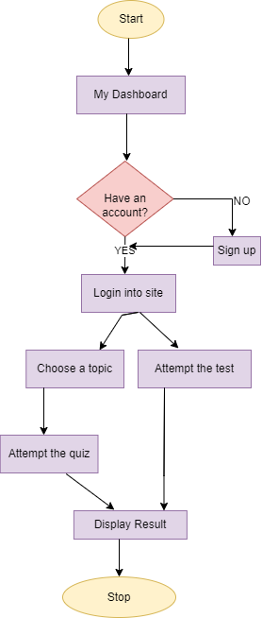

**Fig. 5.1. Flowchart**

**5.2 DFD**

**0 Level Diagram**

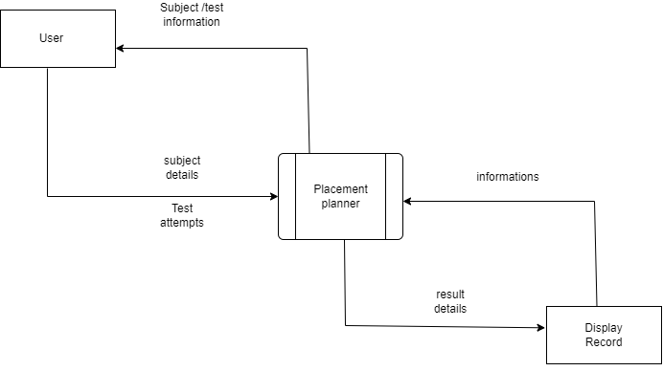

**Fig. 5.2 0 Level Diagram**

**1.Level Diagram**

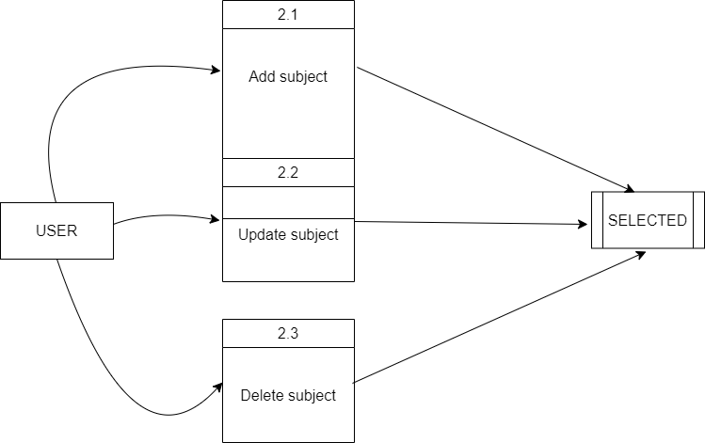

**Fig. 5.2 1 Level Diagram**

**5.3 ER Diagram**

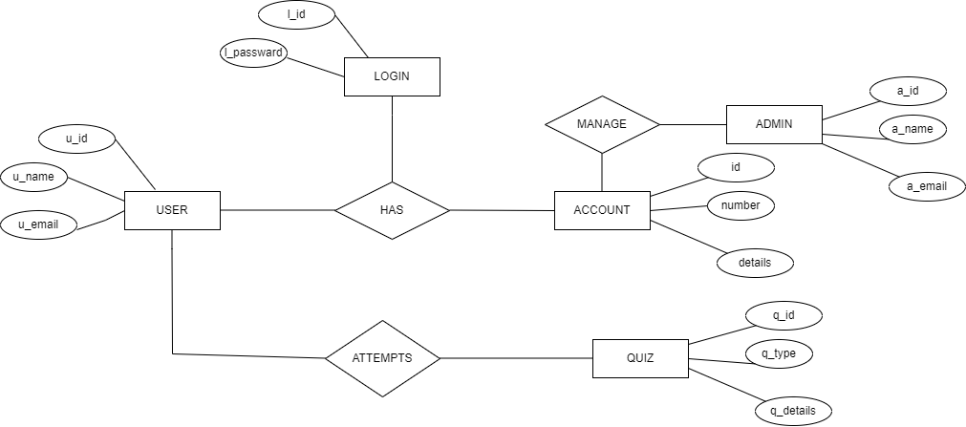

**Fig.5.3 ER Diagram**

**5.4 Use Case Diagram**

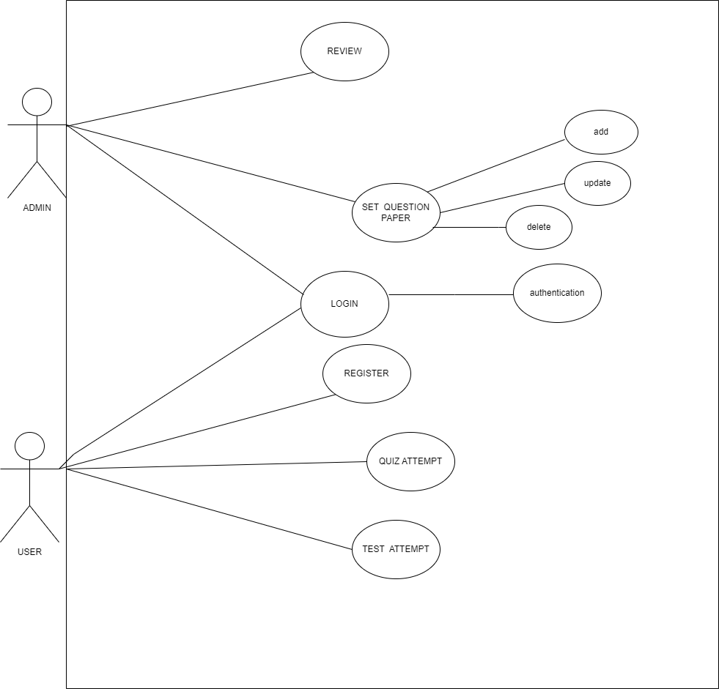

**Fig.5.4. Use Case Diagram**

**CHAPTER 6**

**PROJECT SCREENSHOT**

## **6.1 HOME PAGE**

The home page serves as the entry point to the platform, presenting users with three key modules: Login, Register, and Admin. Its clean and intuitive design ensures ease of navigation for users of all levels.

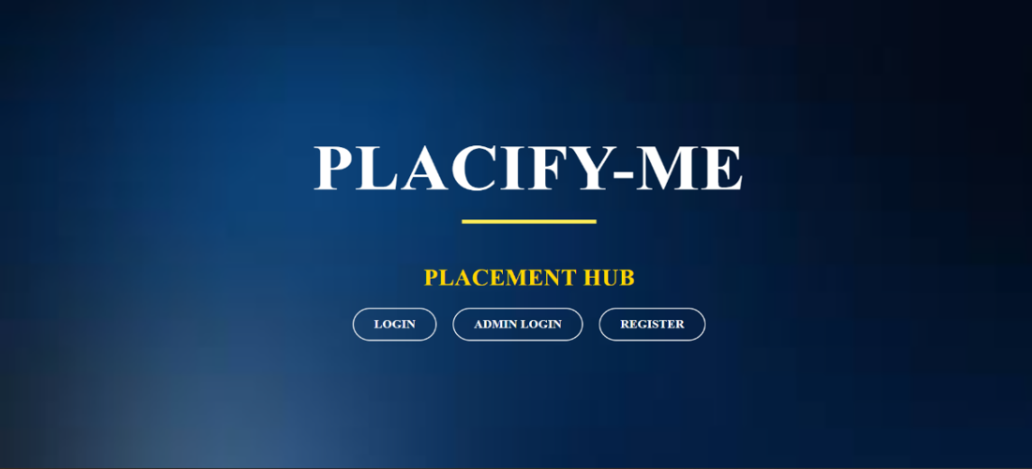

**Fig.6.1 Home Page**

**6.2 USER SIGN-UP PAGE**

The User Sign-Up Page is dedicated to new users aiming to join the platform. It prompts users to enter essential information such as their name, email, college name, and password, streamlining the registration process**.**



**Fig.6.2 User Sign Up Page**

**6.3 USER LOGIN PAGE**

The User Login Page provides a secure gateway for existing users to access their accounts. Users are required to input their email and password to log in successfully.

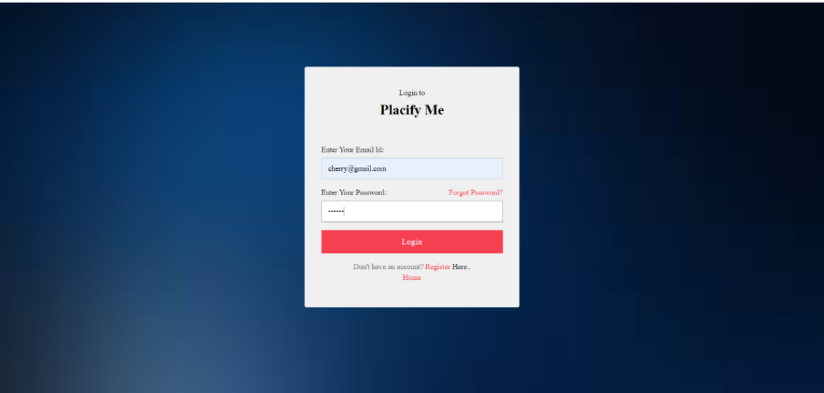

**Fig.6.3 User Login Page**

**6.4 USER DASHBOARD**

Upon successful login, users are directed to the User Dashboard. This centralized hub serves as the starting point for test attempts, providing a user-friendly interface for navigating through various features.

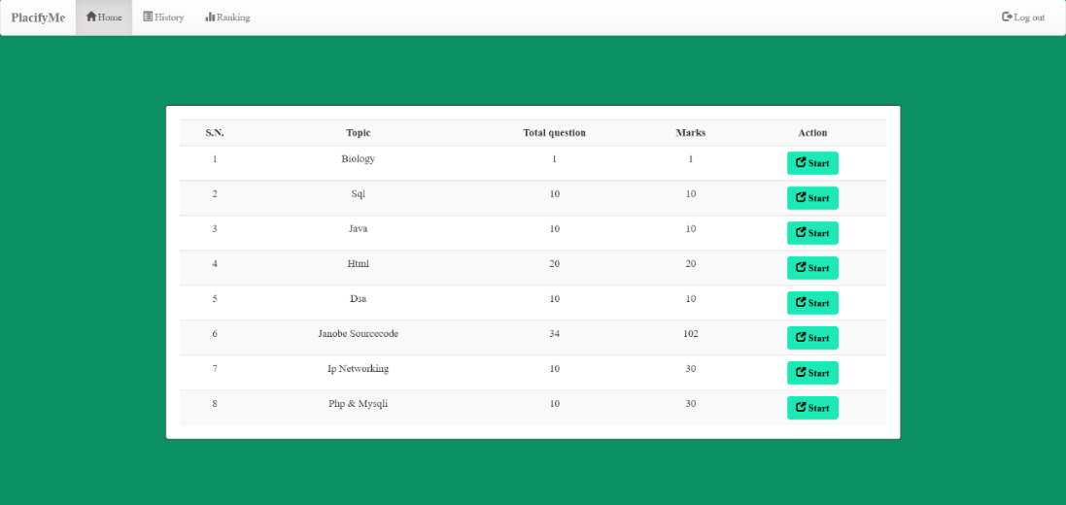

**Fig.6.4 User Dashboard**

**6.5 USER QUIZ PAGE**

The User Quiz Page is where users can explore available quizzes. Organized by topics, users can choose and attempt quizzes based on their preferences.

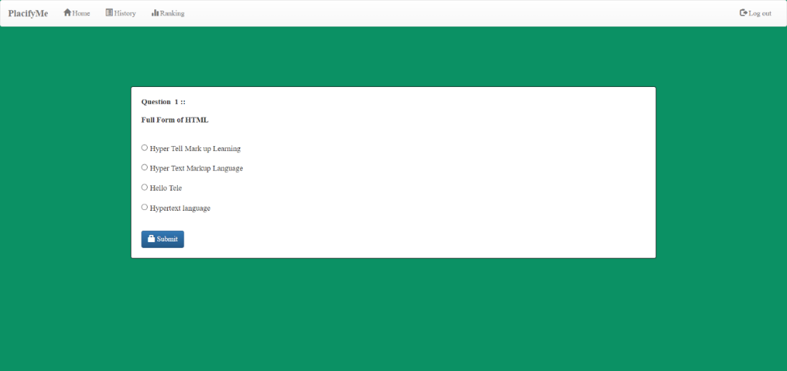

**Fig.6.5 User Quiz Page**

**6.6 USER SCORE PAGE**

After completing a quiz, users can view their results on the User Score Page. It displays details such as right and wrong answers, providing an overview of their performance.

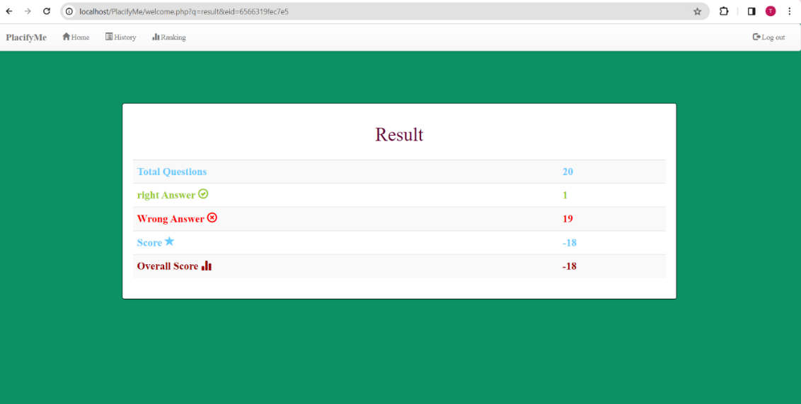

**Fig.6.6 User Score Page**

**6.7 USER HISTORY PAGE**

The User History Page allows users to track their past test attempts. It provides a comprehensive overview of tests taken, including correct and incorrect answers**.**

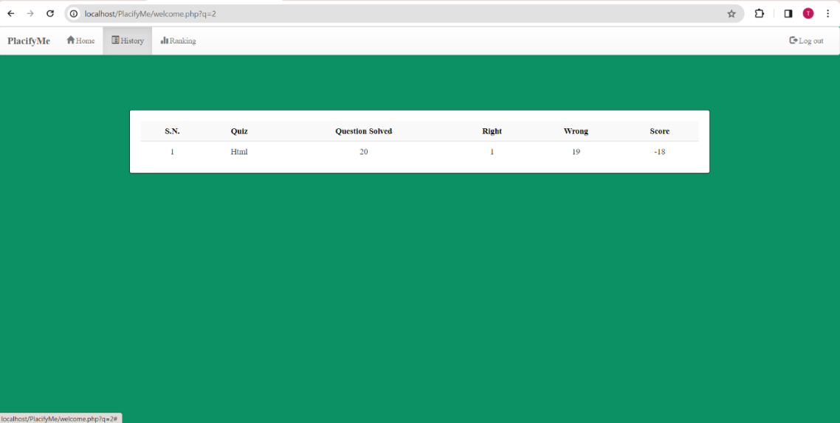

**Fig.6.7 User History Page**

**6.8 USER RANKING PAGE**

On the User Ranking Page, users can check their ranking based on their scores. This feature adds a competitive element, fostering engagement among users.

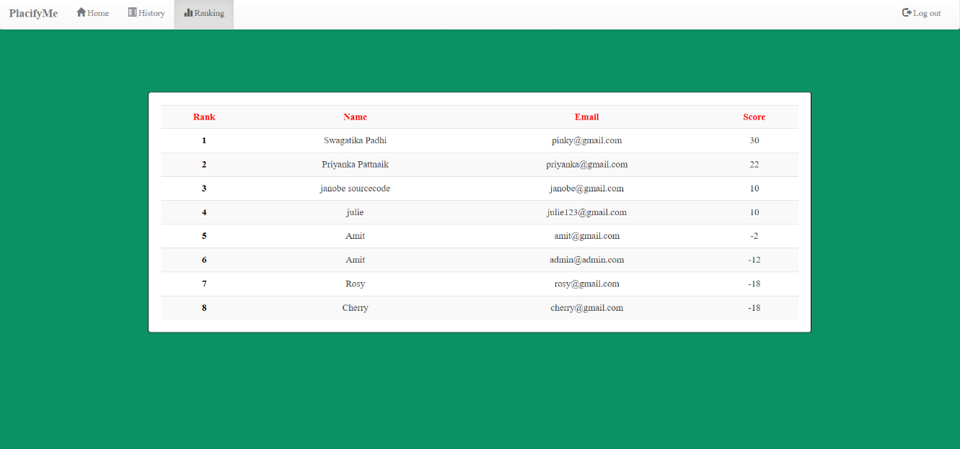

**Fig.6.8 User Ranking Page**

**6.9 ADMIN LOGIN PAGE**

The Admin Login Page is the access point for administrators. To enter the admin dashboard, administrators must input their email and password for authentication.

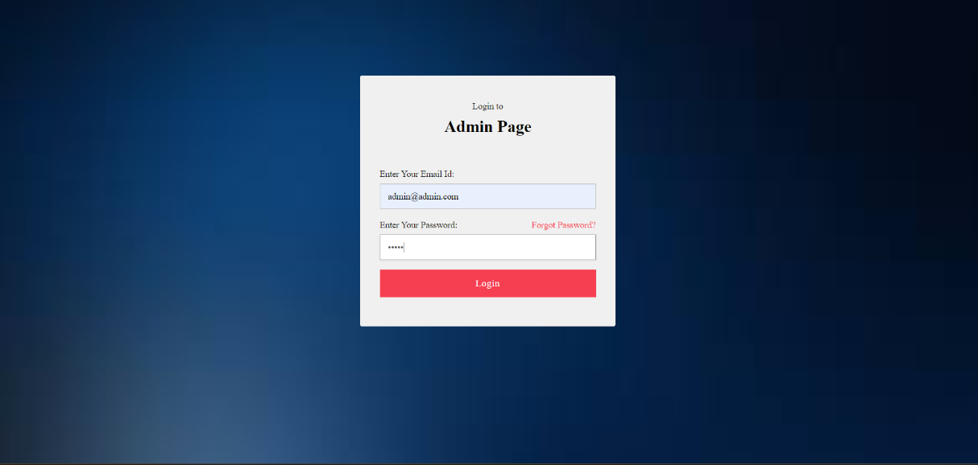

**Fig.6.9 Admin Login Page**

**6.10 ADMIN DASHBOARD**

The Admin Dashboard is a powerful tool for administrators. It features tabs for managing users, rankings, and quizzes. Admins can also add or remove quizzes from the database**.**

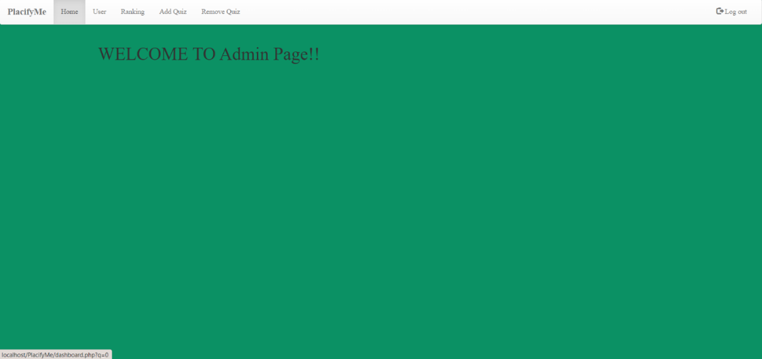

**Fig.6.10 Admin Dashboard**

**6.11 ADD NEW QUIZ**

In the Add New Quiz section, administrators can contribute to the platform's content by adding new quizzes. This feature enhances the variety of quizzes available for users.

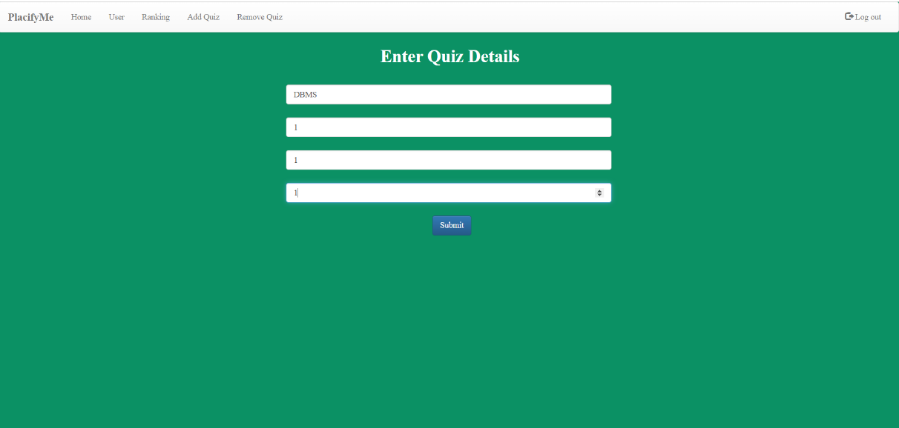**Fig.6.11. Add New Quiz**

**6.12 ENTER QUIZ DETAILS**

Admins enter quiz details, including questions, options, and correct answers, ensuring accuracy and relevance in the quizzes presented to users.

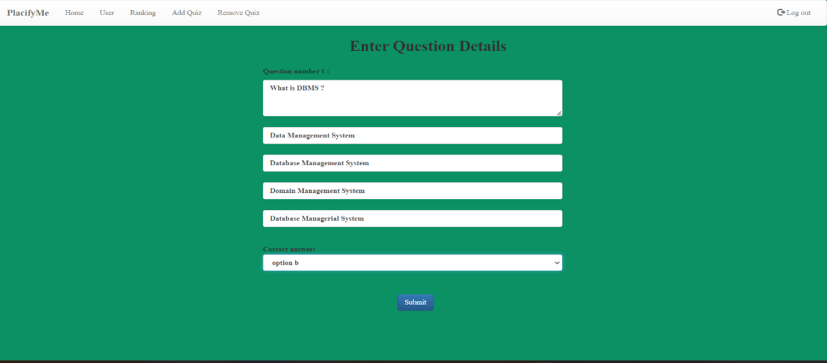

**Fig.6.12 Add Quiz details**

**6.13 REMOVE QUIZ**

Admins have the authority to maintain the platform's quality by removing outdated or irrelevant quizzes through the Remove Quiz feature.

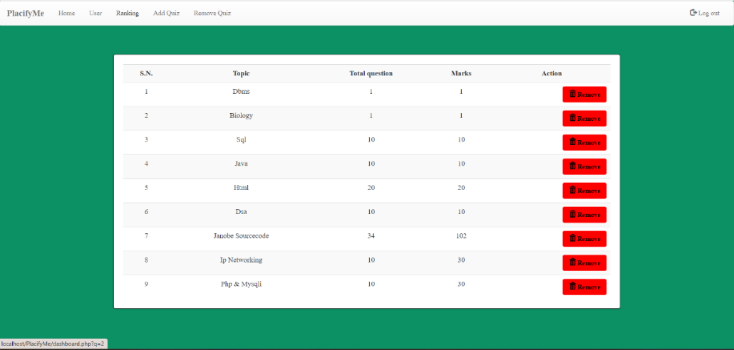

**Fig.6.13 Remove Quiz**

**6.14 REMOVE USER**

Admins can efficiently manage the user database by utilizing the Remove User feature, removing any user deemed necessary for administrative reasons**.**

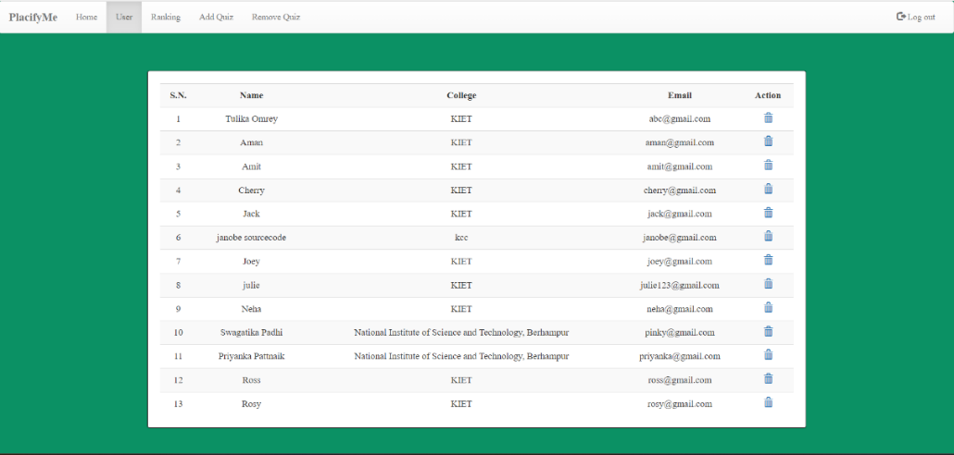

**Fig.6.14 Remove User**

**6.15 TEST SERIES QUESTIONS**

In this section user can attempt the whole test series. The test series will contain the questions from different topics.

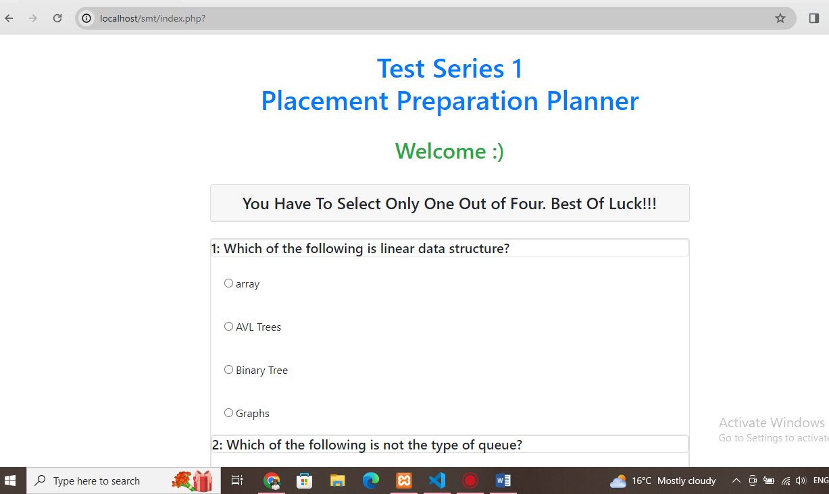

**Fig.6.15 Test series questions**

**6.16 TEST SERIES RESULT**

After completing a test, users can view their results on the resut page. It displays details of your attempted questions and score.

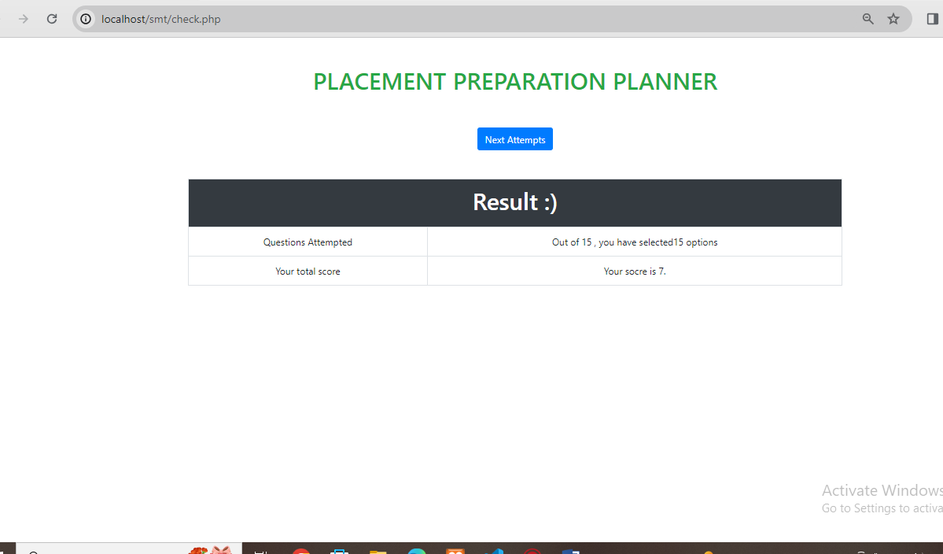

**Fig.6.16 Test series result**

**6.17 TEST SERIES RECORD**

The User Record Page allows users to track their past test attempts. It provides a comprehensive overview of tests taken, including total marks.

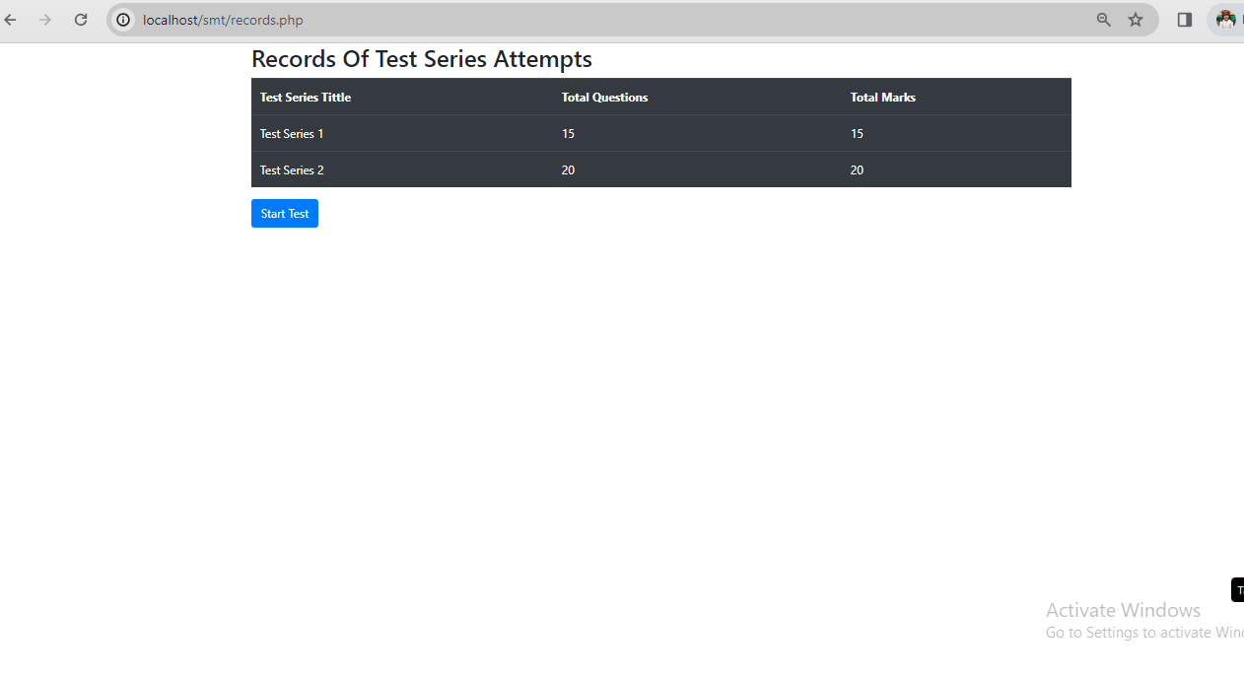

**Fig.6.17 Test series record**

**CHAPTER 7**

**Conclusion and Future Scope**

**Conclusion**

In wrapping up, Placify-Me is here to help students get ready for job placements in a smart and friendly way. With lots of quizzes, tests that feel like the real deal, and cool features like choosing what you want to study, it's made just for you. We're all about giving quick feedback, letting you see how you're doing, and making sure you feel confident. The discussions with other students are like hanging out with friends who share tips and tricks. Placify-Me is not just about getting ready for a job; it's about feeling part of a group all working towards success. We're super excited about helping you shine in your placements**!**

**Future Outlook**

In the future, we're thinking of making it even cooler! Imagine having personalized lessons that know how you learn best or joining live chats with experts. You might be able to practice interviews and get certificates to show off your skills. We want to be on your phone too, making studying easy wherever you are. Placify-Me could team up with schools and even use virtual reality for mind-blowing lessons. It's all about making your journey to success even more awesome, and we're just getting started!

**Bibliography**

1. <https://www.scribd.com/document/440794070/College-Training-And-Placement-System-Project-Report-docx>
2. <https://www.goskills.com/>
3. <https://ieee-uffc.org/education/professional-networking-and-mentorship-program>
4. <https://youtu.be/4b0Ewmy0ffE?si=ruAebJFxGgDBugFa>